

Travis Vanos

Group 3

GISC9301-D2

Introduction to ArcGIS



Mrs. Janet Finlay

Professor – GISC9301 November 12, 2015  
Niagara College GISC9301-D2  
135 Taylor Road  
Niagara-on-the-lake, ON  
L0S 1J0

Dear Mrs. Janet Finlay  
RE: Submission: GISC9301-D2

Please accept this letter as the formal submission of Assignment two: GISC9301 - Introduction to ArcGIS . The purpose of this assignment is to successfully gain familiarity with standard data classifications using ArcMap and perform heads-up digitizing for the Niagara College Campus. The following sections will be fulfilling the deliverables as outlined in the GISC9301-D2 requirements. The following procedures to be covered include, but are not limited to:

* To gain a basic familiarity with standard data classifications
* To gain a familiarity with the creation and editing of feature and attribute data using ArcGIS,
* To edit the respective data in attribute tables
* To become familiar with shapefile to personal geodatabase translations
* To calculate areas using a personal geodatabase

Following the according steps please find the required material sent electronically. Should you have any questions regarding the enclosed documents, or if there are technical issues regarding the files please contact me at your convenience at (937)647 3746 or email at [travis.vanos@gmail.com](mailto:travis.vanos@gmail.com). I eagerly await your comments and suggestions.  
  
Sincerely,

Travis Vanos,  
GIS/GM Candidate, Niagara College  
T. V

Enclosures: VANOSTGISC9301-D2

# Executive Summary

The work encompasses the data collected using proper surveying methods discussed in class and following the Assigned chapters in the "Getting to Know ArcGIS" textbook. Specifically, the procedure will be to manipulate shapefiles and personal geodatabses using both ArcMap and ArcCatalog. Digitizing will also encompass first contemporary local datasets by undertaking ‘heads-up’ digitizing using the Regional Municipality of Niagara’s 20 cm Digital Orthoimagery (panchromatic).

The outcome will be a foundation of skills needed to perform required digitizing and document creation in a completed final works.

Table of Contents

Contents

[Executive Summary i](#_Toc435123451)

[List of Figures iii](#_Toc435123452)

[1.1 Introduction 1](#_Toc435123453)

[1.2 Chapter 8 2](#_Toc435123454)

[a) Give three examples of quantitative data 2](#_Toc435123455)

[b) Give three examples of categorical data 2](#_Toc435123456)

[c) Which of the 6 classification methods that Arcresent the : 2](#_Toc435123457)

[d) For any frequency distribution histogram of classifi y-axis typically 3](#_Toc435123458)

[e) For any frequency distribution histogram 3](#_Toc435123459)

[1.3 ArcGIS Digitizing 5](#_Toc435123460)

[a) What is the total surface area of the Niagara College Glendale Campus Building in m2? 5](#_Toc435123461)

[b) What is the total building footprint size (in m2) of the Greenhouse Facility immediately north of the Campus Ring Road? ... What are the areas of these two parts of the building? 6](#_Toc435123464)

[c) What is area of the wetland lagoon south of the campus, immediately adjacent to the Niagara escarpment? Express you answer in Hectares. What is the perimeter length in metres? 8](#_Toc435123465)

[1.5.2 Closing 11](#_Toc435123466)

## List of Figures

[Figure 1 Niagara College Glendale Campus 4](#_Toc435124096)

[Figure 2Glendale Campus - Building Attribute Table 5](#_Toc435124097)

[Figure 3 Complete Greenhouse Building 6](#_Toc435124098)

[Figure 4 Cut Polygon Option 6](#_Toc435124099)

[Figure 5 Cut PolygonAttribute Table 7](#_Toc435124100)

[Figure 6 Lagoon Without Berm 8](#_Toc435124101)

[Figure 7 Editor Toolbar to Edit Vertices 8](#_Toc435124102)

[Figure 8 Edited Vertices of Lagoon 8](#_Toc435124103)

[Figure 9 Calculate Geometry for Hectares 9](#_Toc435124104)

[Figure 10 Wetlands Table with Calculated Hectares 9](#_Toc435124105)

# Introduction

The enclosed works will showcase the process to successfully gain familiarity with standard data classifications using ArcMap and perform heads-up digitizing for the Niagara College Campus.. The following sections will be fulfilling the deliverables as outlined in the GISC9301-D2 requirements. The following procedures to be covered include, but are not limited to:

* To gain a basic familiarity with standard data classifications using ArcMap,
* To manually classify feature data,
* To map density data,
* To use graduated and chart symbols,
* To create dynamic labels,
* To set rules for label placement,
* To use interactive labels and annotation.
* To gain a familiarity with the creation and editing of feature and attribute data using ArcGIS,
* To edit the data,
* To become familiar with shapefile to personal geodatabase translations,
* To calculate areas using a personal geodatabase.

# 1.2 Chapter 8

## a) Give three examples of quantitative data (not from the exercises) Elevation of Niagara Escarpment Population density of Ontario Average Depth of Lake Ontario

## b) Give three examples of categorical data (not from the exercises Gender Eye colour of Niagara College Students ethnicity  of people

## c) Which of the 6 classification methods that ArcGIS offers would you use to represent the following data sets (explain your choice):

|  |
| --- |
| i) Income data for seven distinct neighborhoods in Thorold. The income data appear to be clustered into ranges of low ($0 to $20,000 per annum), middle ($40,000 to $70,000) and high ($110,000 to $200,000) due to the employment base in Thorold.  Although a method such as equal interval or defined interval can be used to display household income, in this situation, because of the unevenly distributed data, natural-breaks (Jenks) classification would suit best because the ranges. The ranges as specified as low, middle, high do not contain the same amount of units in each range and there is a large gap between the income ranges i.e 70,000 to 110, 000.   “Natural-breaks classes are based on natural groupings inherent in the data, and boundaries are set where there are relatively large gaps between values. Developed by Professor George Jenks of the University of Kansas, this method is useful for classifying unevenly distributed data such as population” (Law & Collins, 2013, p. 264). |
| ii) Air quality Index data (1 to 100 as an index score) for the Niagara Region. There are 45 monitoring sites distributed evenly across Niagara. A score of 1 to 40 is acceptable air quality, 41 to 50 is marginal air quality, 51 to 60 is poor, while 61 to 100 is dangerous to human health.  As the index score is determined as a defined scale of 1 – 100, a manual classification is needed for the range of air quality scores. The range is pre-determined and defined ranges are already present with the data. To present the data you must manually define the ranges and adjust the histogram accordingly. |
| iii) The tested IQs (intelligence quotients) of students by school. You are informed that the mean IQ is 113 for the school district and that one standard deviation is 7.54 IQ points.  For the best visualization for information such as IQs of a given population the data is best viewed as a deviation from a mean value. For this data-set a Standard Deviation Classification would be best-suited as IQ data is typically distributed in a bell-shaped curve and each end has a higher deviation from the mean value.   “Data that you know is normally distributed (in a bell-shaped curve) can benefit from standard-deviation classification. This method created classes according to a specified number of standard deviations from the mean value.”   (Law & Collins, 2013, p. 264).  iv) A Raster data set from the TERRA Satellite’s ASTER sensor (near infrared or NIR band). Each raster cell has a value (digital number or DN) that ranges from 0 to 255. You are interested in detecting the location of healthy deciduous trees that will exhibit raster values in a range of 198 to 212 or a secondary range of 223 to 248. |
| For the display of the specified a defined range is best suited for this dataset. A desired interval can be set for the range and you may choose which ranges are then displayed on the present map. For these two distinct data ranges, two ranges will be used, with the interval defined if both ranges were desired to appear on the map |

## d) For any frequency distribution histogram of classified data, what does the y-axis typically represent?

For the frequency distribution histogram the y-axis would typically show the frequency of the data presented in the x-axis. The graph is easily read for the even distribution of data along the breaks defined on the x-axis.

## e) For any frequency distribution histogram of classified data, what does the x-axis typically represent?

For the frequency distribution histogram the x-axis would typically show the range of value presented in the data-set. The breaks in the ranges can be set and adhere to one of the (7) classification methods used to display data-sets.

## f) Knowing what you now know (after completing Chapter 7), re-answer question 2.c. from Assignment #1. Highlight changes that you would make knowing how graduated symbology and iconic symbolization using classification work.

Previously, question 2.c from Assignment #1 asked to display the according data of the West Nile Virus among the dead crows and blue jays within the specified municipalities. Having a layer already defined for the borders with the municipalities defined, we can then choose the appropriate scale for viewing. With the added knowledge of graduated symbology and iconic symbolization, two (2) layers will be used for the municipality polygon feature class and another for the visual representation of the West Nile virus as a pie chart for the different bird species.

The municipalities as a blander, less-vibrant colour and a stronger hue for the data-set of West Nile incidents. Looking at the ratio of blue jays to crows in the area a pie chart would show an obvious contrast to the two datasets. The chart of choice would include the data and two colours (blue for blue jays and red for crows for example) showing the number of infected for each species. Simply looking at the size and contrast between the two sets would give a good indicator, without analysing the data in the table, as to which area needed the attention.

# 1.3 ArcGIS Digitizing

## a) What is the total surface area of the Niagara College Glendale Campus Building in m2?

## Digitizing of the Glendale Campus Building can be seen in Figure 1. The determined are is 7225.4055m2 .

## C:\Users\Travis\AppData\Local\Microsoft\Windows\INetCache\Content.Word\glendale_campus.png

Figure 1Niagara College Glendale Campus

## C:\Users\Travis\AppData\Local\Microsoft\Windows\INetCache\Content.Word\building table.png

Figure Glendale Campus - Building Attribute Table

## b) What is the total building footprint size (in m2) of the Greenhouse Facility immediately north of the Campus Ring Road? ... What are the areas of these two parts of the building?

The entirety of the Greenhouse building can been seen digitized in *Figure 3.* The total footprint size was determined to be 2085.5 m2.

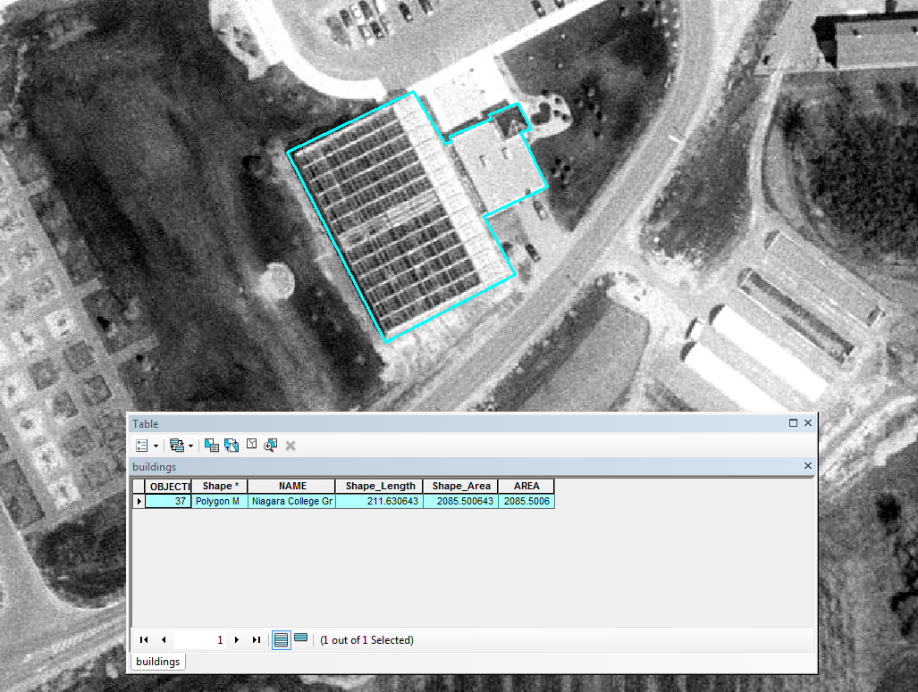

Figure Complete Greenhouse Building

After the polygon has been completed cutting the polygon into two separate polygon feature classes with two unique ID's Using the "Cut Polygon Tool" and highlighted in *Figure 4*.



Figure Cut Polygon Option

After the polygon feature class has been cut and the edits were saved, you can notice two polygons were formed with two separate, unique OBJECT ID's with each area calculated. As can be seen in *Figure 5* the areas of the two polygons are 1720.58m2 and 364.92m2.

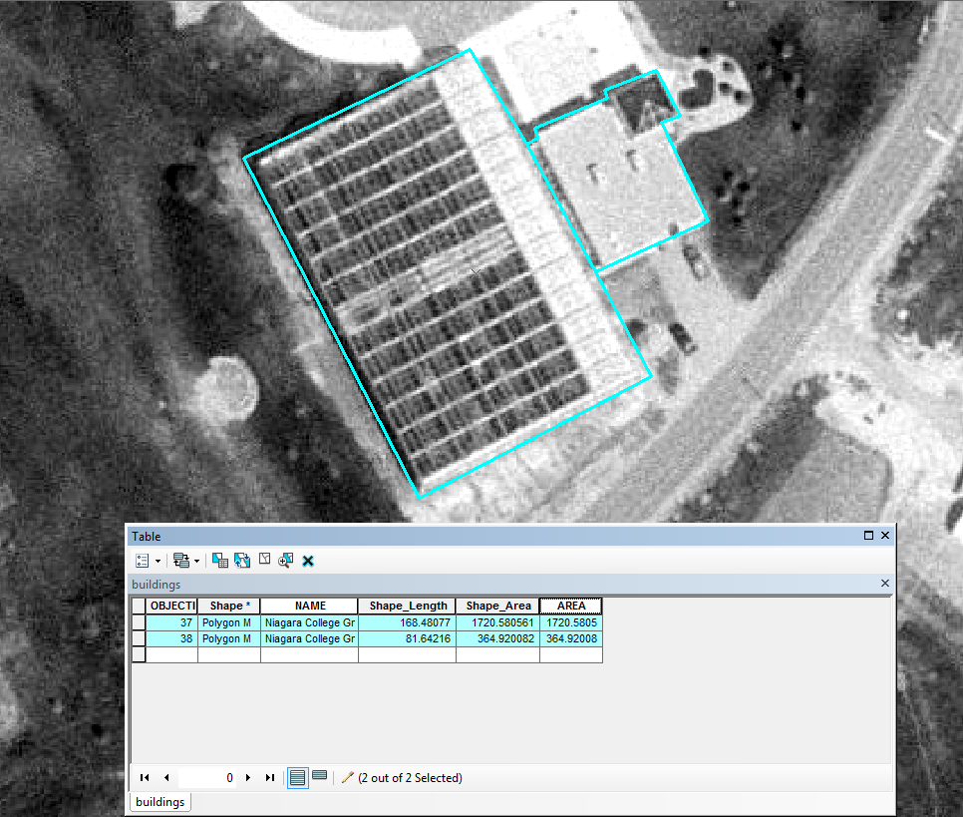

Figure Cut Polygon Attribute Table

## c) What is area of the wetland lagoon south of the campus, immediately adjacent to the Niagara escarpment? Express you answer in Hectares. What is the perimeter length in metres?

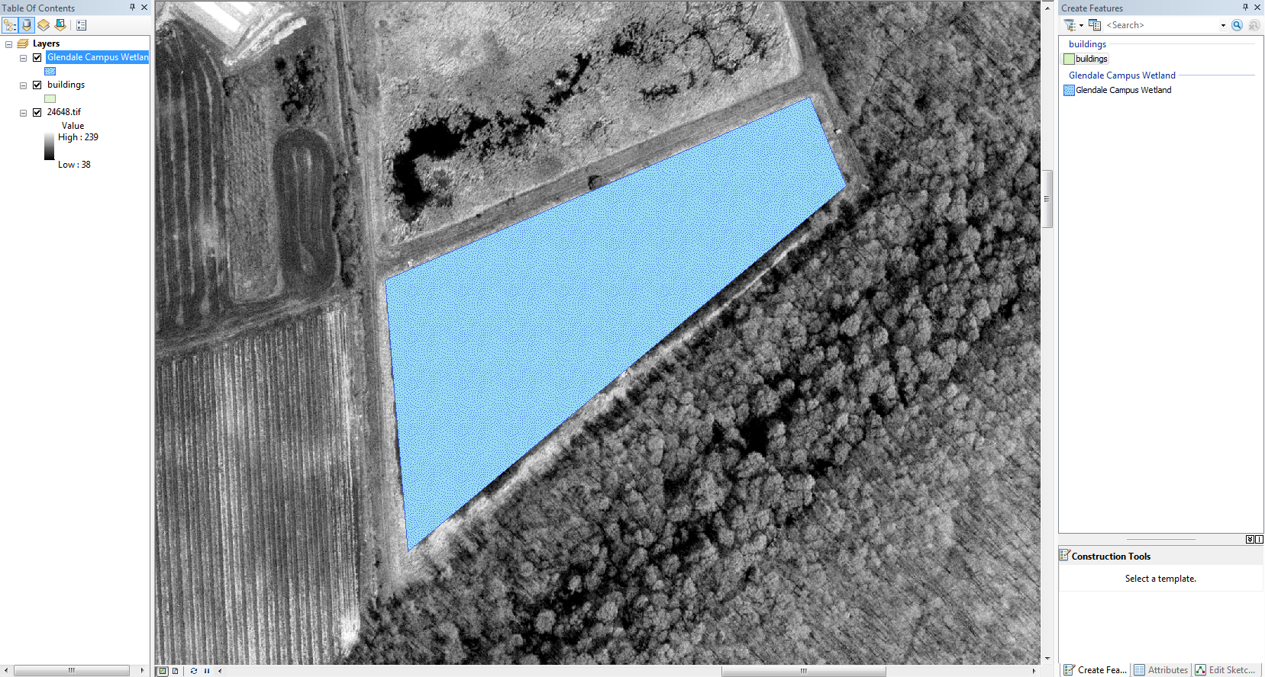

Figure Lagoon Without Berm

Using the editor toolbar the edit vertices is used to pull out the vertices to include the berm.

C:\Users\Travis\AppData\Local\Microsoft\Windows\INetCache\Content.Word\toolbar_editor.png

Figure Editor Toolbar to Edit Vertices

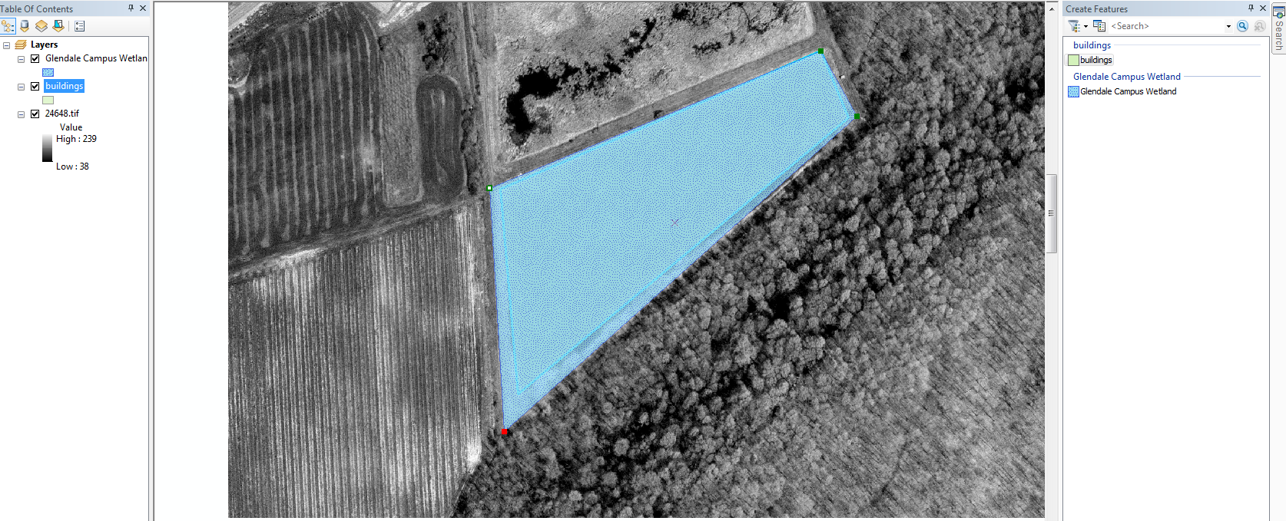

Figure Edited Vertices of Lagoon

Right clicking and selecting "Calculate Geometry" will allow you to recalculate the edited polygon in Hectares rather than m2.

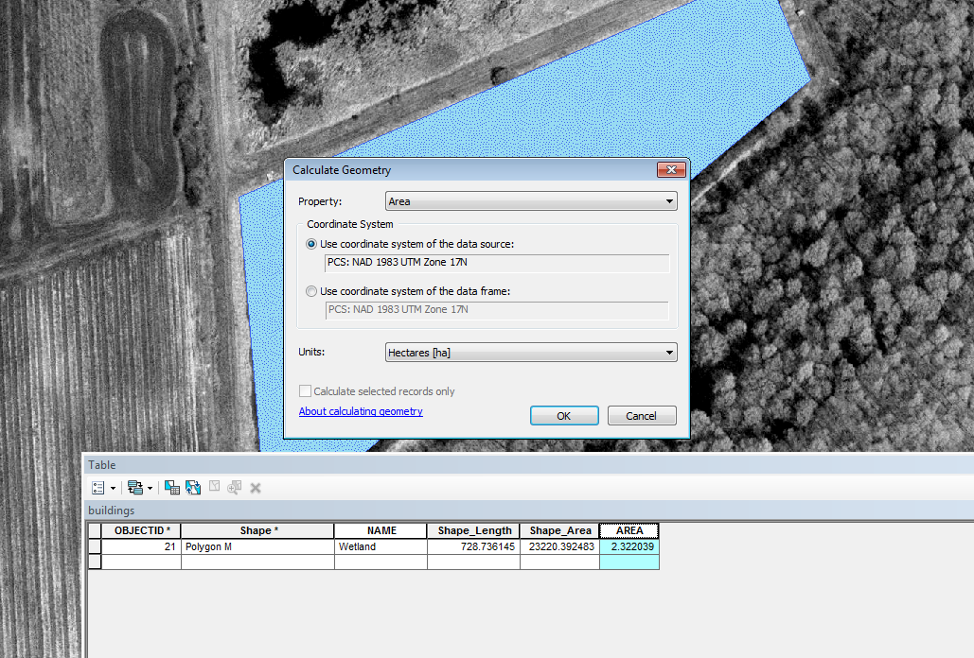

Figure Calculate Geometry for Hectares



Figure Wetlands Table with Calculated Hectares

## 1.3.2 Closing

As outlined in the GISC9301-D2 requirements the completed findings works for the introduction to ArcGIS digitizing and graduated symbology have been presented. Following the assignment procedures, data has been collected and corrected for measurements in relation to the provided Regional Municipality of Niagara’s 20 cm Digital Orthoimagery (panchromatic).

**References**

Law, M., & Collins, A. (2013). Getting to know ArcGIS for desktop (4th ed.). Redlands, California, USA: ESRI Press.